3 color - full color LED Module

Overview：
This project will use a three-color RGB LED module to generate red - blue - green color sequence.

Materials：
Arduino Uno x 1
RGB Led x 1
DuPont wires x 4

Product description :
The three-color RGB module is composed of three LED lights, red, green and blue. The color intensity of the three lights can be adjusted individually (using PWM).

Technical Parameters ：
Size: 15mm * 19.6mm
PCB Colour: Black
3 x 5mm full color super bright LEDs
Current limiting resistor to prevent burning LEDs
High level light output LED
Working voltage: 3.3V / 5V
Weight: 4g

Wiring diagram:
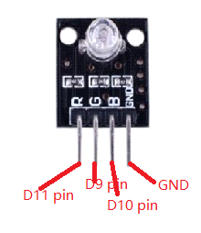
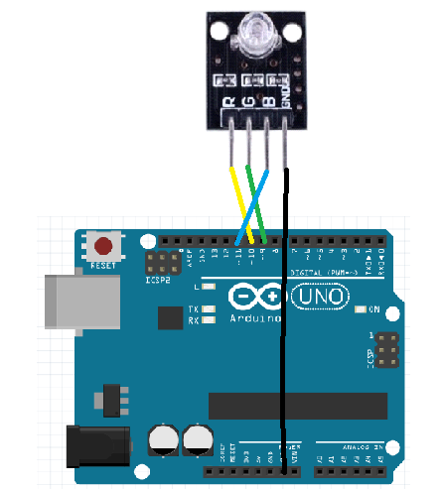

Example code:
int redpin = 11; //select the pin for the red LED
int bluepin =10; // select the pin for the blue LED
int greenpin =9;// select the pin for the green LED

int val;

void setup() {
pinMode(redpin, OUTPUT);
pinMode(bluepin, OUTPUT);
pinMode(greenpin, OUTPUT);
Serial.begin(9600);
}

void loop()
{
for(val=255; val>0; val--)
{
analogWrite(11, val);
analogWrite(10, 255-val);
analogWrite(9, 128-val);
delay(1);
}
for(val=0; val<255; val++)
{
analogWrite(11, val);
analogWrite(10, 255-val);
analogWrite(9, 128-val);
delay(1);
}
Serial.println(val, DEC);

Experimental phenomena：
RGB module will change from red to blue to green.

